Getting our strength back
Call: The peace of the Lord be with you.
Response: And also with you.
Introduction:
Watch the video of the Eagle flying on the web page, Think about how it makes you feel. Would you like to fly like this eagle? Do you feel scared? Excited? Joyful? Overwhelmed?
Our theme for this Collective Worship is one of our Christian Values- Hope. How would you finish this sentence:
I hope that…..
See if you can think of 5 ways to finish it!
Bible Verses:
Here are some verses from the prophet Isaiah, chapter 40:
Even youths grow tired and weary,
and young men stumble and fall;
but those who hope in the Lord
will renew their strength.
They will soar on wings like eagles;
they will run and not grow weary,
they will walk and not be faint.
Activity: If you were an eagle, soaring above your house, your town, your city now, what would you see? How would you feel? If you could fly anywhere, where would you go? You could draw a picture of what you think you would see from up there in the sky. Do you think you might see some of these things?
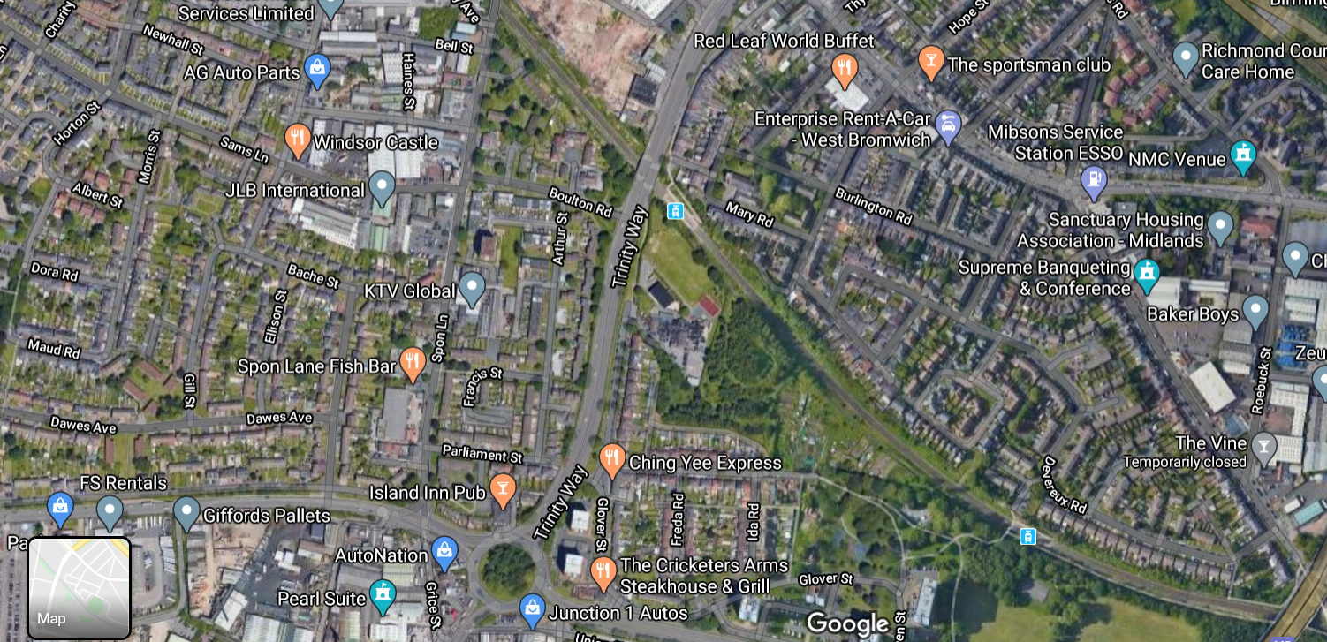

Reflection:
Our verse from Isaiah tells us that even young people can get tired, fed up and weary. But if we put our hope in God, he will give us our strength back. He will make us like the eagle in the video clip, so that we can soar and fly.
Jesus lost all his strength when he was put to death on a cross. But God raised him to life again, and gave him his strength back. When we hope in God, he has the power to raise us up and give us strength and life back, even when we are tired and weary.
Prayer:
Dear Lord,
We thank you that we can put our hope in you. You brought Jesus back from the dead when all his strength and life had gone. And you also promise to give us our strength back when we hope in you. Help us to put all our hope in you for the future.
Amen.
Call: Go in peace to love and serve the Lord.
Response: In the name of Christ, Amen.

